d) To program a robot to deliver a parcel to a consumer's doorstep, navigating through traffic, turns, and obstacles, you'll need to integrate several components: perception sensors, motion control, path planning algorithms, and communication modules. Here’s a structured approach to achieve this:

1. Perception Sensors

1) Lidar (Light Detection and Ranging) or RGB-D Cameras These sensors provide 3D mapping and obstacle detection capabilities. They help the robot perceive its environment and identify obstacles, pedestrians, and other vehicles.
2) Wheel Encoders To track the robot’s movement and ensure accurate positioning.
3) GPS and IMU (Inertial Measurement Unit) For localization and navigation over larger distances.

2. Motion Control

1) Motor Controllers Interface between the robot’s control system and its actuators (motors). They regulate speed, torque, and direction of the wheels or other locomotion mechanisms.
2) Kinematic Model Defines how the robot’s movements (linear and rotational velocities) translate into wheel speeds or other locomotion commands.
3) PID Controllers Provide smooth and stable motion control by adjusting motor commands based on feedback from sensors like wheel encoders.

3. Path Planning and Navigation

1) Mapping Use Lidar or RGB-D data to build a map of the environment, including static and dynamic obstacles.
2) Localization Estimate the robot’s pose (position and orientation) relative to the map using sensor fusion techniques (GPS, IMU, wheel encoders).
3) Path Planning Algorithms Determine an optimal path from the current location to the delivery destination considering obstacles, traffic, and dynamic changes in the environment.
(a) A* (A-star) or Dijkstra’s Algorithm - Plan a collision-free path on the map.
(b)Local Obstacle - Avoidance Implement reactive methods like Potential Fields or Rapidly-exploring Random Trees (RRT) to avoid dynamic obstacles encountered during navigation..

4. Traffic and Dynamic Environment Handling

1) Communication Enable the robot to receive traffic information or dynamically updated maps through wireless communication (e.g., LTE, Wi-Fi).
2) Real-time Decision Making Incorporate algorithms that can dynamically reroute based on real-time traffic conditions or unexpected obstacles.

5. High-Level Control and Decision Making

1) Task Management Coordinate parcel pickup, navigation to the destination, and interaction with the recipient (e.g., notifying arrival).
2) User Interface Develop a user-friendly interface for monitoring the robot’s status, providing commands, and handling exceptions (e.g., rerouting due to road closures).

Implementation Example: Code and Circuitry

1) ROS (Robot Operating System) Utilize ROS for modular development and integration of perception, control, and planning modules.
2) Python/C++ Implement algorithms such as SLAM (Simultaneous Localization and Mapping), A* path planning, PID control, and communication protocols.
3) Microcontroller/Embedded Systems Use Arduino or Raspberry Pi for interfacing sensors and actuators, and executing navigation algorithms.
4) Motor Drivers H-Bridge circuits or motor driver boards for controlling DC motors or stepper motors.
5) Power Management Ensure sufficient power supply for all components and motors.

Assumptions and Conclusion

Assumptions might include predefined maps or limited variability in weather conditions (if applicable). Real-world deployment would require extensive testing for robustness and reliability, including edge cases like sudden obstacles or communication failures.

In summary, developing a delivery robot involves integrating advanced sensors, robust motion control systems, sophisticated path planning algorithms, and reliable communication protocols. This ensures safe and efficient navigation through urban environments, ultimately enabling successful parcel delivery to consumers' doorsteps.

IDEATION

Problem Statement

Program a robot such that it can carry out the assigned task of delivering the parcel to the consumer doorstep navigating the traffic, turns and other obstacles

Key Requirements

- Balance and Stability The robot must maintain balance and stability while moving on two wheels.
- Autonomy The robot should be able to navigate through various environments without human intervention.
- Task Performance The robot should be able to perform tasks such as personal transportation or last-mile delivery.
- Safety The robot should ensure the safety of its users and the environment.

Implementation Strategy

- Brainstorming Identify key components and technologies required, including sensors, actuators, and control systems.
- Research Study existing TWSBR designs and technologies to understand their strengths and limitations.
- Concept Development Develop a concept, including its design, components, and control system.
- Prototyping Create a prototype to test its performance and identify areas for improvement.
- Testing and Validation Test the robot in various environments and scenarios to validate its performance and ensure safety.

Key Components and Technologies

- Sensors Gyroscopes, accelerometers, and cameras to detect the robot's orientation, movement, and environment.
- Actuators Motors and gearboxes to adjust the robot's speed and direction.
- Control System A sophisticated algorithm that adjusts the motor speeds based on the sensor data to maintain balance and stability.
- Power Supply A reliable power supply to ensure the robot's continuous operation.
- Frame and Wheels A sturdy frame and wheels designed for stability and mobility.

Design and Implementation

- Frame and Wheels Design a sturdy frame and wheels that can support the robot's weight and provide stability.
- Sensor Integration Integrate the sensors into the robot to detect its orientation, movement, and environment.
- Control Algorithm Development Develop a sophisticated control algorithm that adjusts the motor speeds based on the sensor data to maintain balance and stability.
- Motor Control Implement motor control systems to adjust the robot's speed and direction.
- Power Supply Design a reliable power supply to ensure the robot's continuous operation.

Optimization Considerations

- Cost Efficiency Evaluate component costs versus performance gains, focusing on cost-effective solutions without compromising reliability.
- Scalability Design systems scalable for deployment in various urban environments, accommodating different parcel sizes and delivery demands.
- Energy Efficiency Optimize power management strategies, including regenerative braking and low-power standby modes, to extend operational range.

Conclusion

The ideation process for the TWSBR involves identifying key components and technologies, researching existing designs, developing a concept, prototyping, testing, and validating the robot's performance. The key components and technologies include sensors, actuators, control systems, power supplies, and frame and wheels. The design and implementation involve designing the frame and wheels, integrating sensors, developing the control algorithm, implementing motor control, and designing a reliable power supply.

DIAGRAMS

Below are some hand-made diagrams for clear understanding:
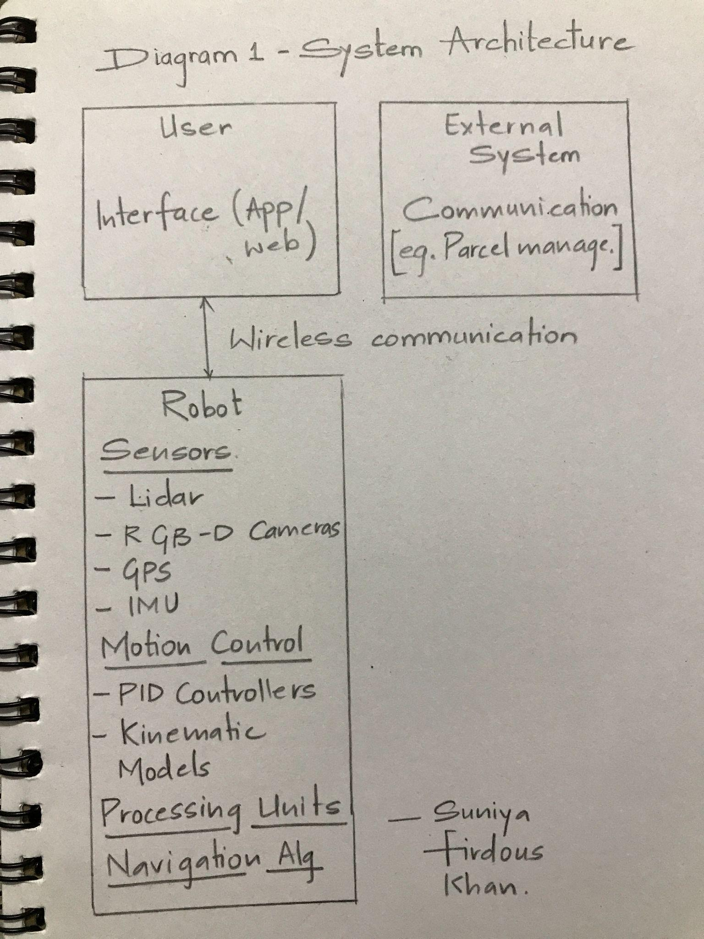
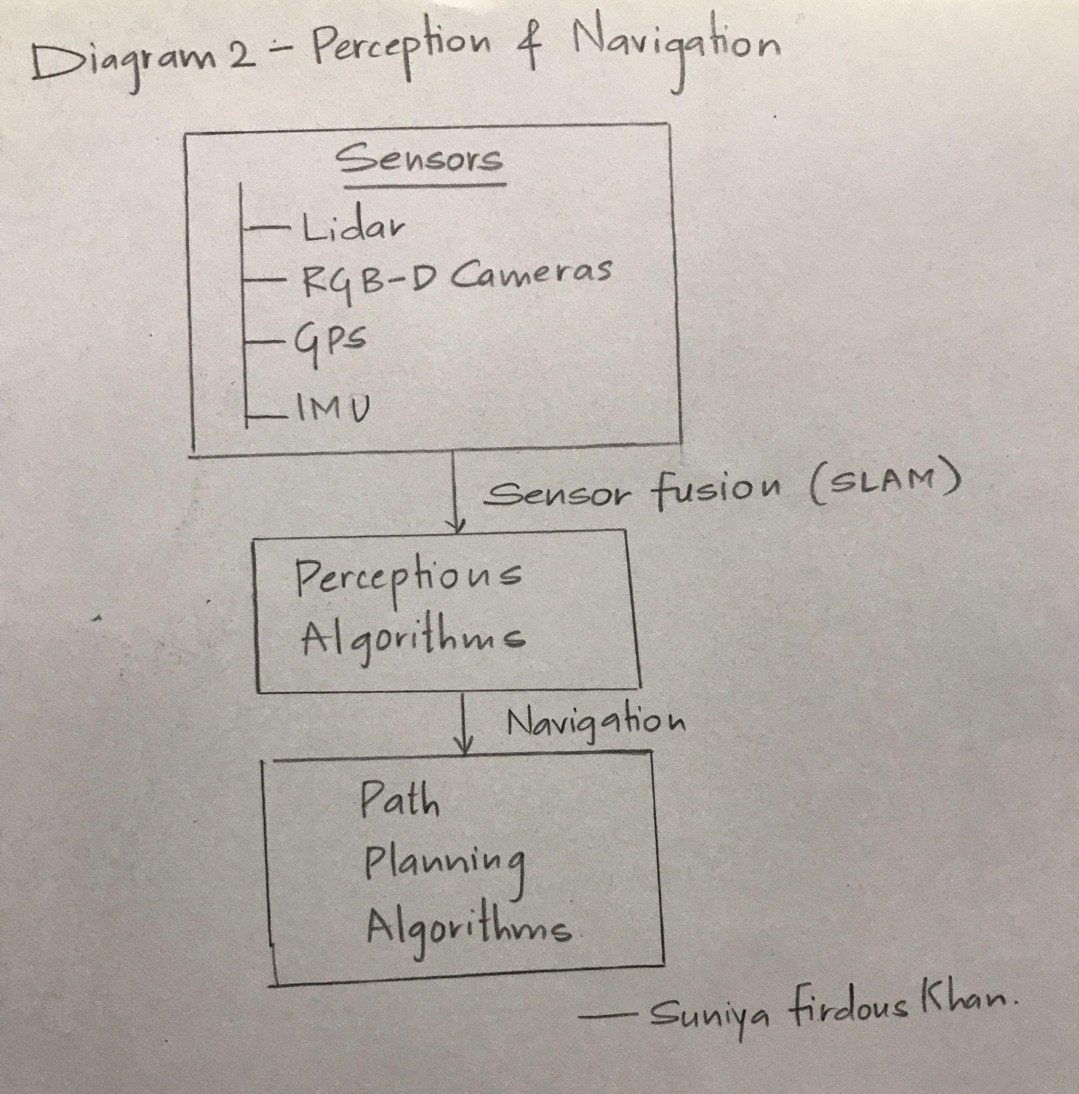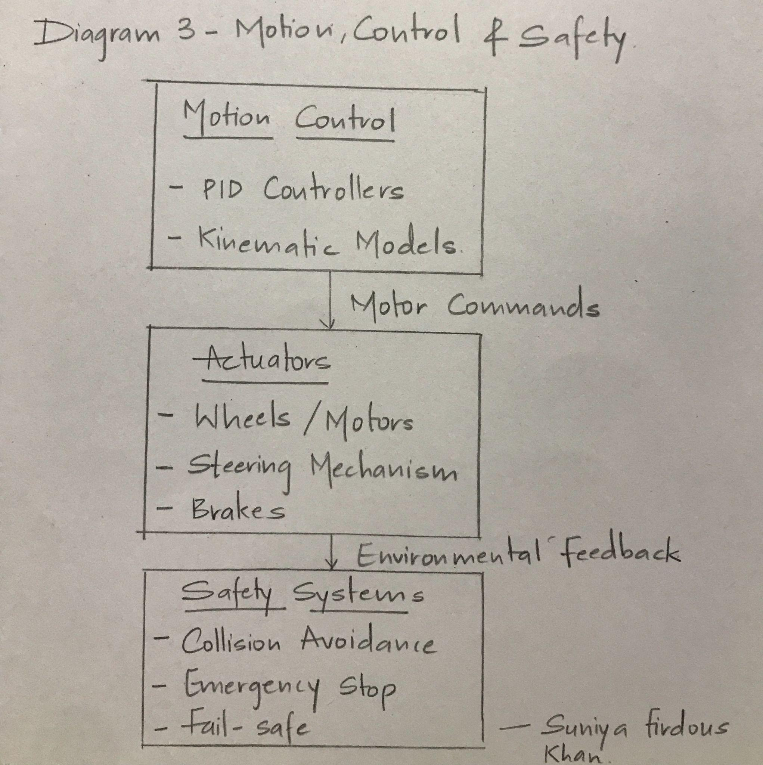

THEORY

Autonomous parcel delivery robots are designed to navigate urban environments, interact with users, and safely deliver parcels to specified destinations without human intervention. The development and programming of such robots involve integrating advanced hardware and software components to achieve efficient and reliable operation. Below are the key theoretical aspects involved:

1. Sensing and Perception

Objective : Robots must perceive their surroundings accurately to navigate and interact safely with the environment.

- Sensors Utilize a combination of sensors such as Lidar, RGB-D cameras, GPS, and IMU.
- Perception Algorithm Implement algorithms for Simultaneous Localization and Mapping (SLAM) to create and update a map of the environment in real-time.
- Object Recognition Use computer vision techniques to detect and classify objects like pedestrians, vehicles, and obstacles.

2. Navigation and Path Planning

Objective : Plan optimal routes from pickup to delivery points considering obstacles, traffic, and dynamic changes in the environment.

- Path Planning Algorithms Implement algorithms like A* (A-star) or Dijkstra's algorithm to compute efficient paths.
- Dynamic Obstacle Avoidance Integrate methods such as Potential Fields or Rapidly-exploring Random Trees (RRT) to avoid unexpected obstacles in real-time.
- Global and Local Planning Combine global path planning with local adjustments to ensure continuous navigation in dynamic environments.

3. Motion Control

Objective : Ensure precise and smooth motion execution based on planned paths and environmental feedback.

- PID Control Develop Proportional-Integral-Derivative (PID) controllers to regulate motor speeds and ensure accurate movement.
- Kinematic Models Implement models that convert desired velocities and trajectories into motor commands suitable for the robot's actuators (e.g., wheels or legs).

4. Communication and Interaction

Objective: Facilitate seamless communication between the robot, users, and external systems for task management and operational updates.

- Wireless Communication: Integrate communication protocols such as Wi-Fi or LTE for real-time data exchange.
- User Interfaces: Develop interfaces for users to interact with the robot, including parcel pickup requests and delivery notifications.

5. Safety and Reliability

Objective: Implement safety mechanisms to ensure the robot operates safely in shared urban spaces.

- Emergency Stop Systems Include fail-safe mechanisms to halt operations in emergencies.
- Collision Avoidance Use sensor data and algorithms to avoid collisions with pedestrians, vehicles, or other objects.
- Robustness Testing Conduct rigorous testing to validate the robot's reliability and safety under various conditions.

6. Testing and Validation

Objective: Validate the functionality and performance of the robot through simulation and real-world testing.

- Simulation Environments Use tools like Robot Operating System (ROS) and Gazebo for simulated testing of algorithms and navigation strategies.
- Field Testing Conduct real-world tests to evaluate navigation accuracy, obstacle avoidance capabilities, and overall operational efficiency.

7. Adaptability and Scalability

Objective: Design the robot system to accommodate future enhancements and operational scalability.

- Modular Architecture Use a modular design approach to facilitate hardware and software upgrades.
- Future Technologies Plan for integration of advanced sensors, AI algorithms, or autonomous fleet management systems as technology advances.

8. User-Centric Design

Objective: Ensure interfaces and interactions are intuitive and user-friendly for seamless parcel delivery operations.

- User Experience (UX) Design Design interfaces that allow users to easily interact with the robot, track parcel deliveries, and provide feedback.
- Customer Support Integration Incorporate mechanisms for users to receive support and assistance during interactions with the robot.

Conclusion

Programming an autonomous parcel delivery robot involves a multifaceted approach that integrates sensing, perception, navigation, motion control, communication, safety, testing, adaptability, and user-centric design principles. By addressing these theoretical aspects comprehensively, engineers can develop robust and efficient robots capable of navigating complex urban environments and delivering parcels autonomously, contributing to the advancement of logistics and last-mile delivery solutions.

CALCULATIONS

Below are some calculations performed:
- Coordinate Transformation
- A* Algorithm
- PID Control
- Potential Fields
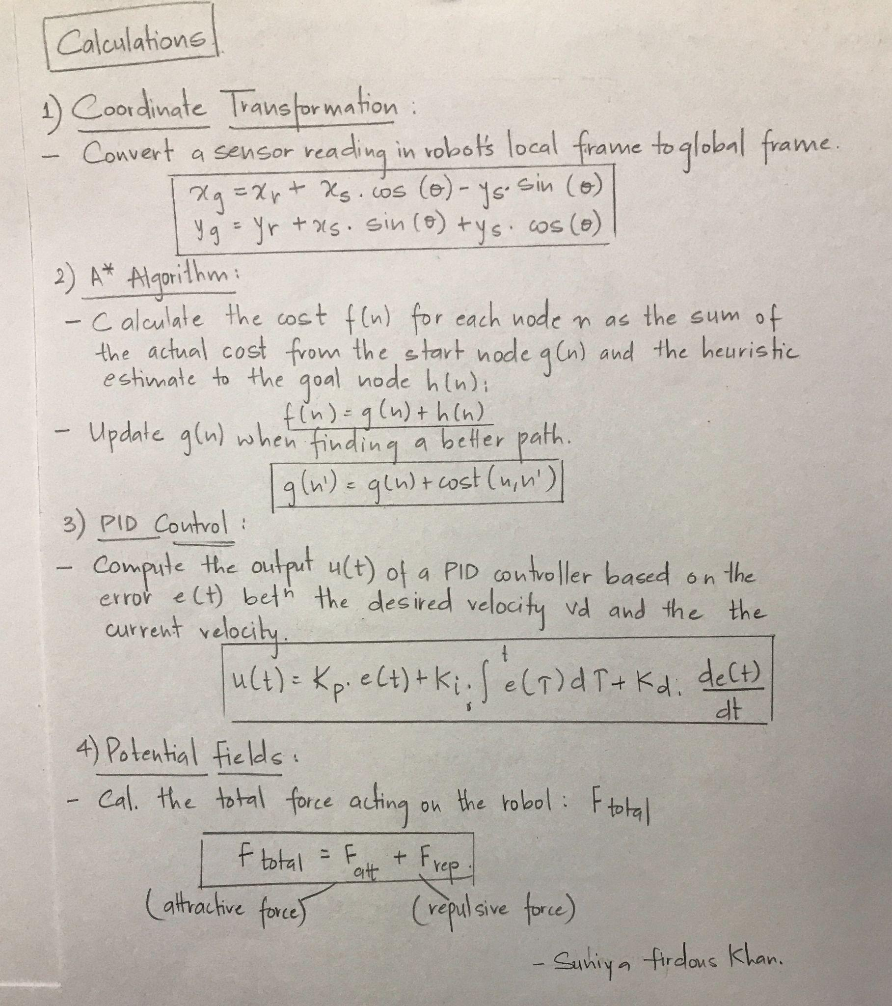

REFERENCE

SOURCES OF INFORMATION by Mahatma Gandhi Central University
Definitions and meanings by Collins Dictionary
(Mostly, I tried to present with my information)

